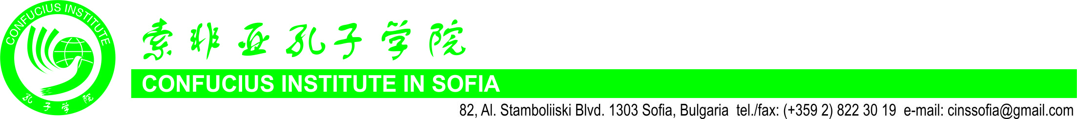

INVITATION LETTER

Dear colleagues,

In the uncertain times of the global pandemic, the need for communication within the academic community, the exchange of ideas and research results are becoming more relevant than ever. True to its mission to develop international exchange and cooperation in the fields of education, science, culture, economics and other aspects, this year for the sixth consecutive time the Confucius Institute at Sofia University “St. Kliment Ohridski” will unite scientists from all over the world around the timeless Silk Road, which has become a symbol of centuries of intercultural dialogue in times of peace and turbulence. We cordially invite you to participate in the Sixth International Scientific Conference “The Silk Road”, which will be convened online on June 4 and 5, 2021.
The conference aims with the help of modern technology to continue and build on the rich cultural exchange between China and the world, between East and West, hence it covers a wide range of topics in the field of Chinese and Oriental studies:

- Chinese language and literature - traditions, modernity and perspectives.
- Current trends of Chinese studies in Bulgaria and Bulgarian studies in China.
- The spiritual tradition, philosophy and culture of China – development, influences and interactions.
- The Silk Road as a link between civilizations – history, archaeology, routes for exchange of material and spiritual values and achievements, economic, social and cultural processes.
- Contemporary China and the world – social-economic dynamics, domestic policies and international relations, trends, ideas and development perspectives.
- Historical and cultural heritage of China, cultural exchange and tourism.
- Chinese traditional and contemporary art – features, influences and perspectives.

The working languages of the conference are Bulgarian, English and Chinese.
The Application form (attached to this letter) and a brief abstract (up to 300 words) in English must be submitted electronically by April 30, 2021 to the following e-mail address: silkroad.conference@gmail.com. Acceptance notification is due by May 06, 2021.
The full size papers (up to 20 000 Cyrillic/Latin symbols with spaces, or 8000 Chinese characters) in Bulgarian, English or Chinese should be sent to the above e-mail address by July 30, 2021 in order to be included in the Conference’s book of proceedings. We recommend that presentations are made in English.

We look forward to your participation and to meeting you on the Silk Road!

Organizing committee of “The Silk Road” International Conference,
Confucius Institute in Sofia

